**E-Learning System**

CSE 308: Software Engineering and Information System Design (Collaboration & Class Diagram)

**Group no. : 06**

**1005062**

**1005065**

**1005071**

**1005072**

**1005074**

SUB SYSTEMS

1. Exam Subsystem
   1. Schedule Management Sub subsystem
   2. Question Management Sub subsystem
   3. Marks Management Sub subsystem
2. Registration Subsystem
3. Information Management Subsystem
4. Virtual Classroom Subsystem

1.1 SCHEDULE MANAGEMENT

“Set schedule” use case

sequence Diagram for use case “set schedule”

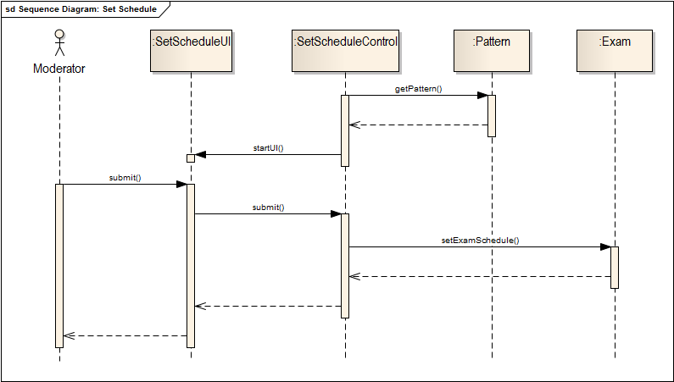

“Update schedule” use case

sequence Diagram for use case “Update Schedule”

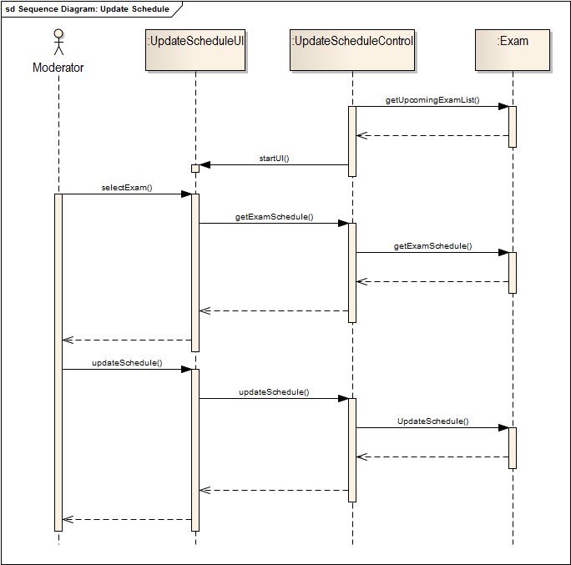

“View Schedule” use case

sequence Diagram for use case”View Schedule”

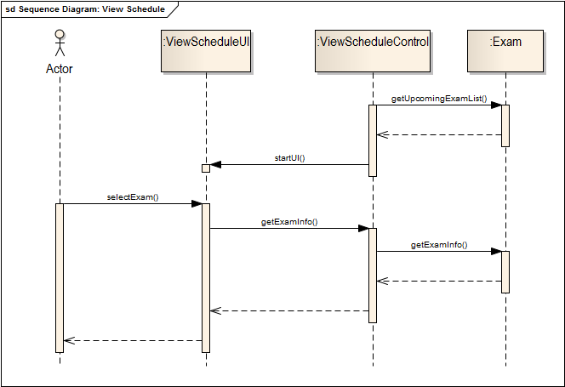

“Registration” use case

sequence Diagram for use case ”registration”

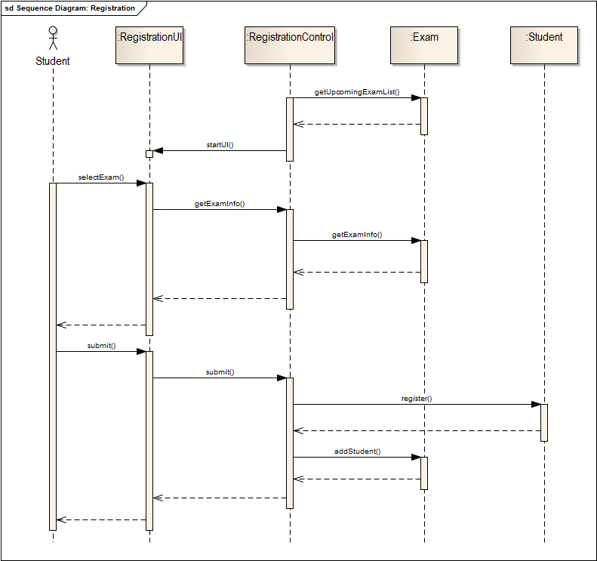

“Appear Exam” use case

sequence Diagram for use case “Appear Exam”

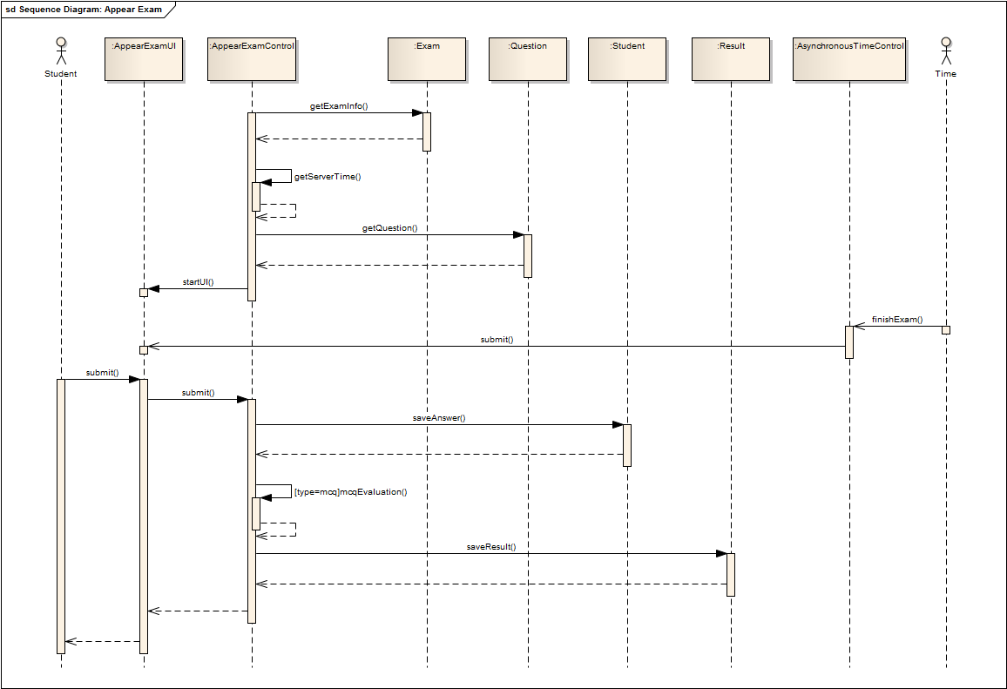

1.2 QUESTION MANAGEMENT

“Provide Question” use case

sequence Diagram for use case ”Provide Question”

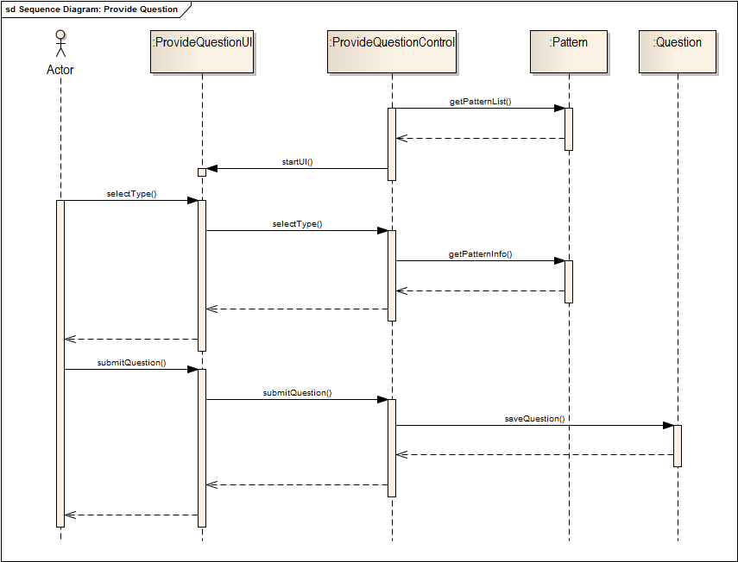

“Review Question” use case

sequence Diagram for use case ”Review Question”

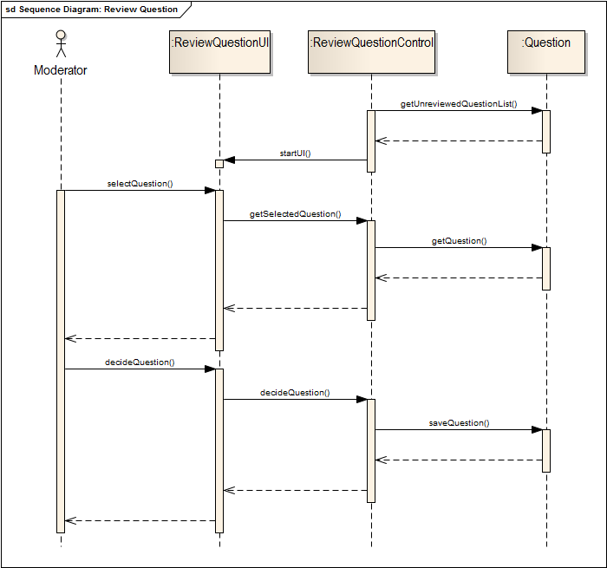

“Select Question” use case

sequence Diagram for use case ”Select Question ”

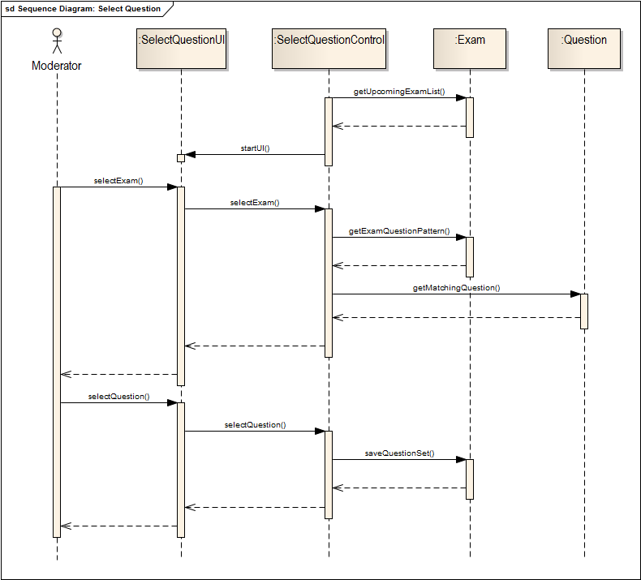

“Set Pattern” use case

sequence Diagram for use case ”set pattern”

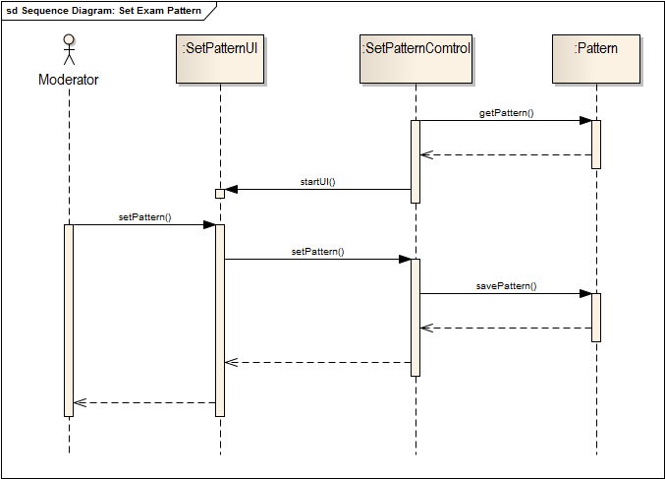

1.3 RESULT MANAGEMENT

“Descriptive Exam Evaluation” use case

sequence Diagram for use case“Descriptive Exam Evaluation”

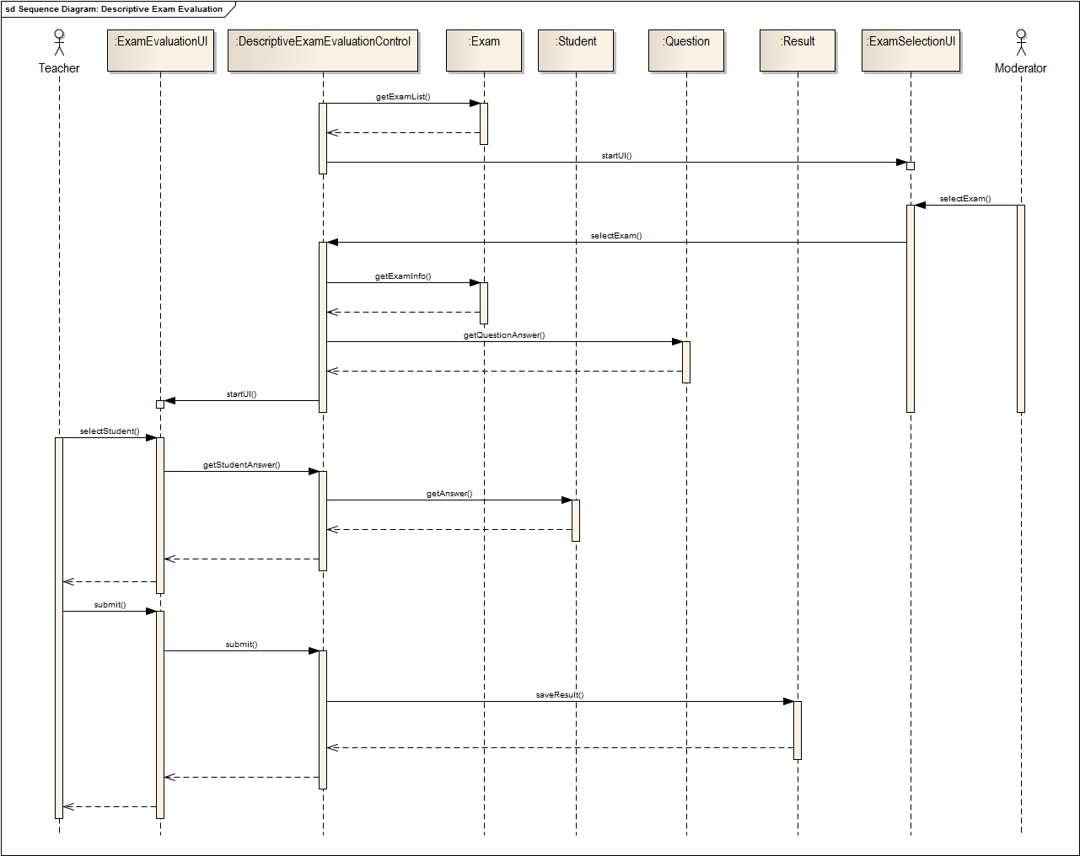

“Ask For scrutiny” use case

sequence Diagram for use case ”Ask for scrutiny”

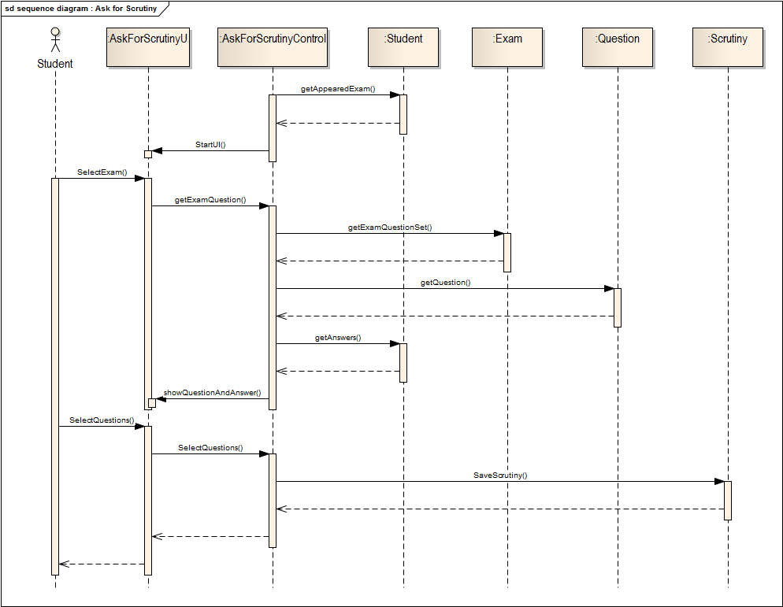

“Scrutiny” use case

sequence Diagram for use case “Scrutiny”

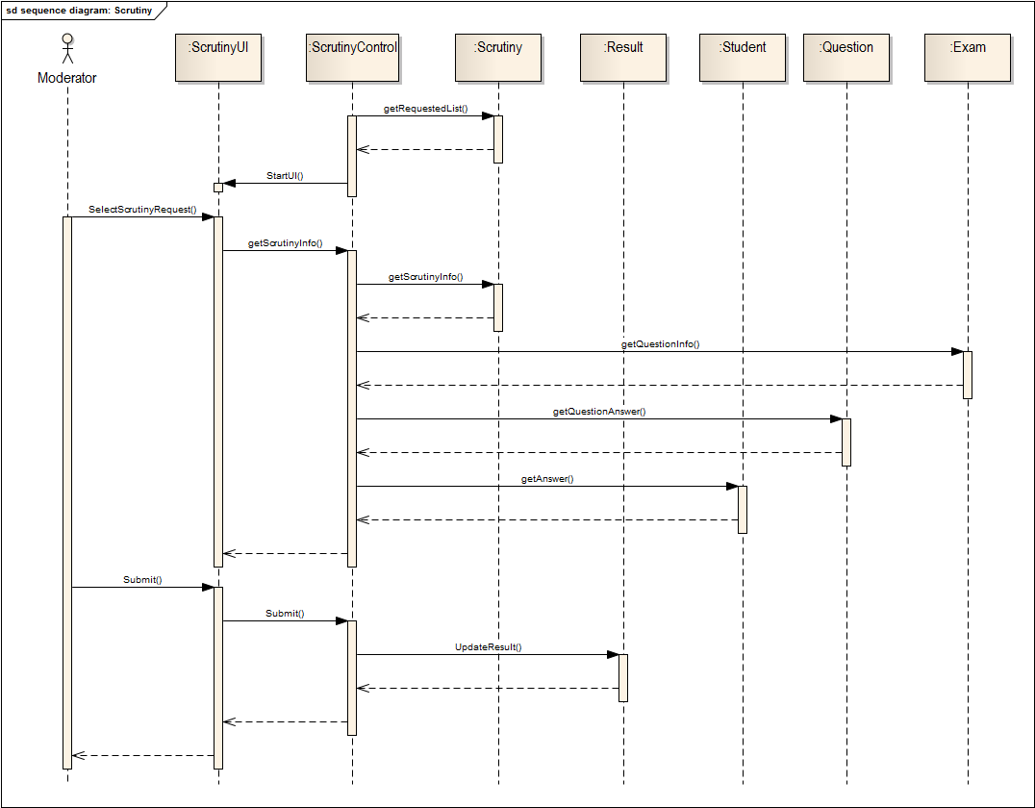

“View Result” use case

sequence Diagram for use case ”View Result”

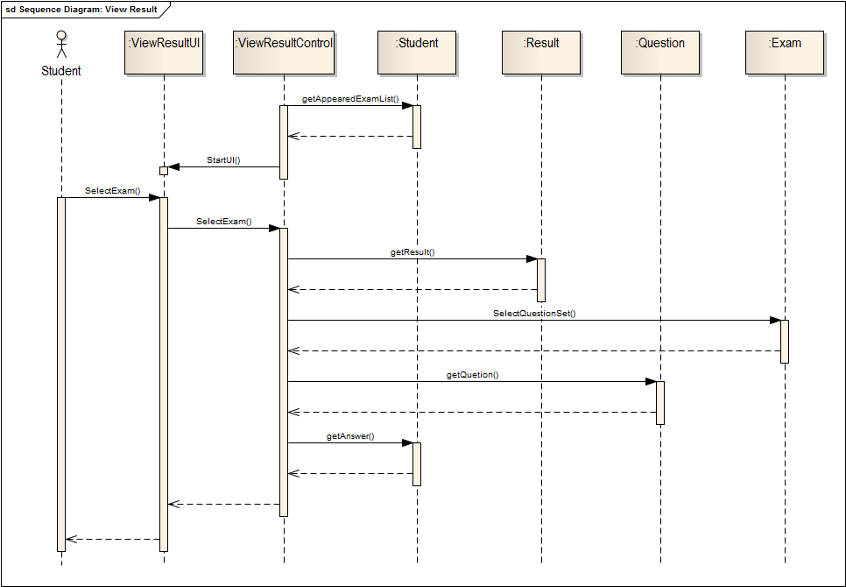

State chart diagram

State chart Diagram for Exam entity

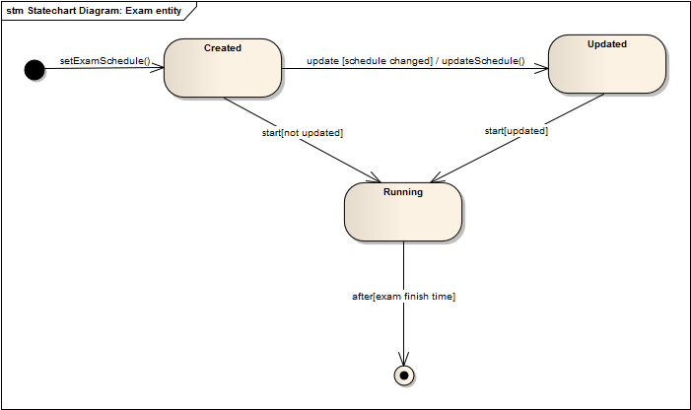

State chart Diagram for pattern entity

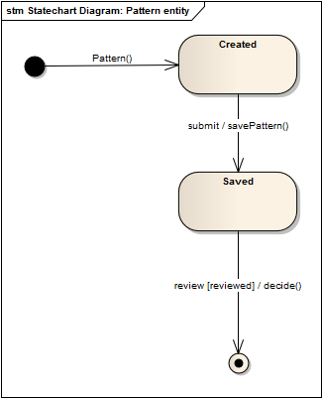

State chart Diagram for Question entity

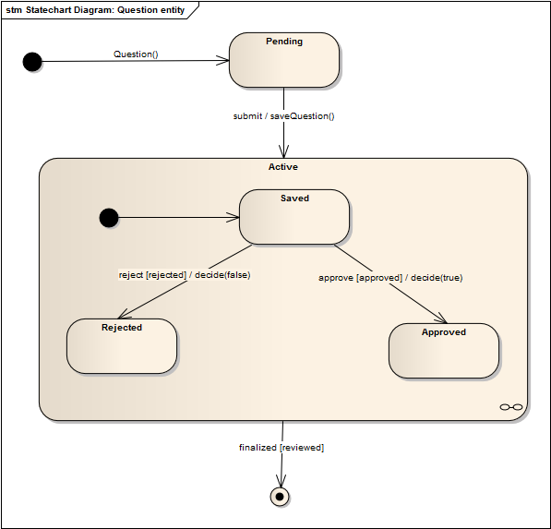

State chart Diagram for result entity

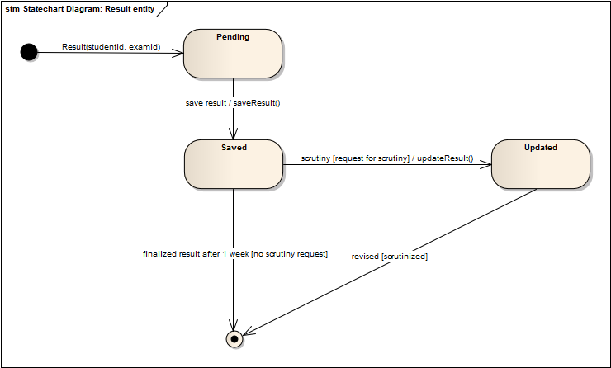

Activity diagram

Activity Diagram for schedule management sub-sub system

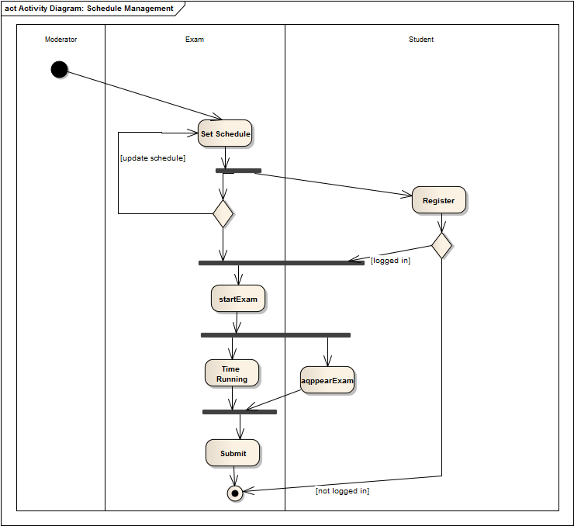

Activity Diagram for schedule select Question

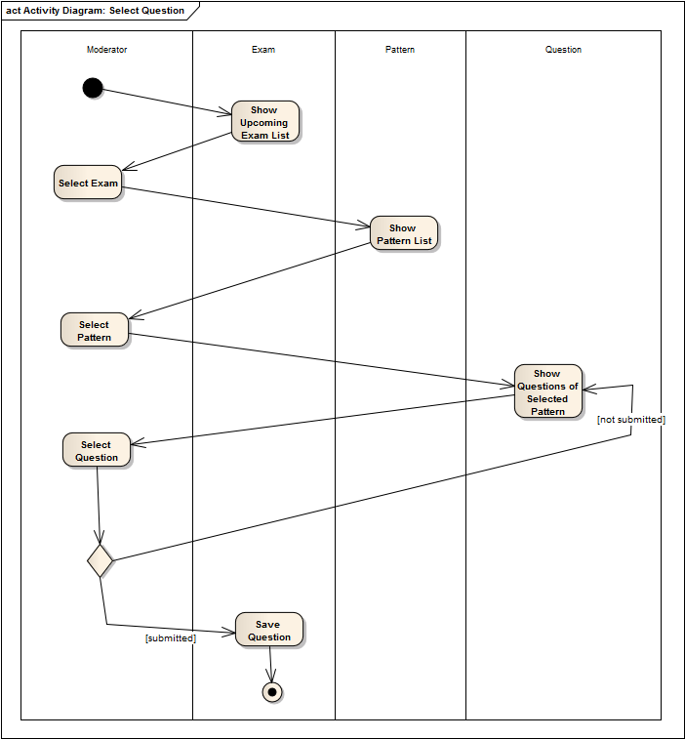

Activity Diagram for schedule Set Question

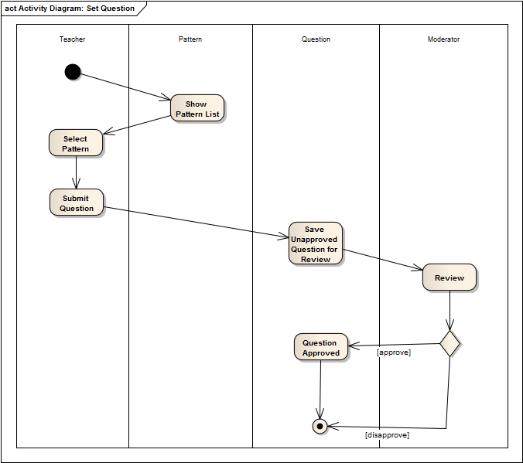

Activity Diagram for ask for scrutiny use case

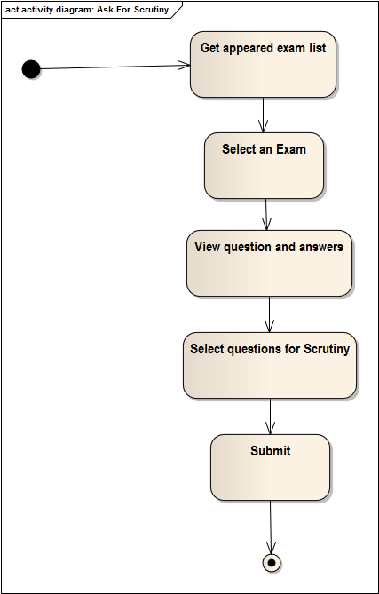

Activity Diagram for ask for descriptive question evaluation use case

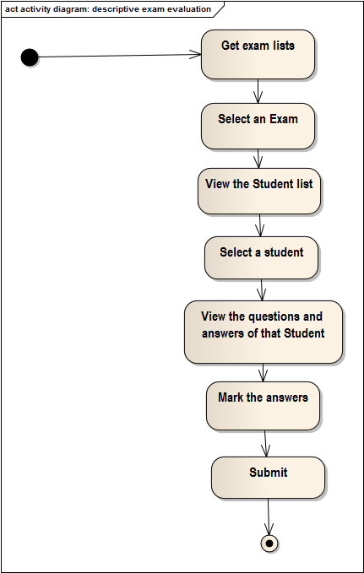

Activity Diagram for scrutiny use case

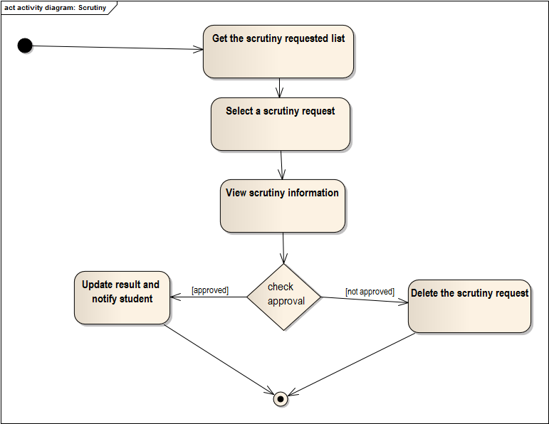

Activity Diagram for view result use case

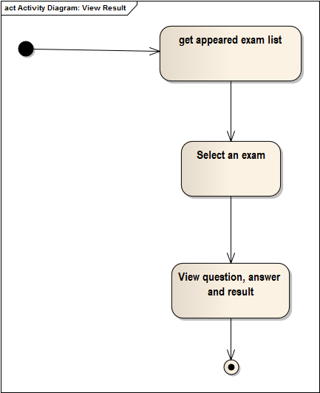

2. REGISTRATION SUB SYSTEM

“Assign moderator” use case

sequence Diagram for use case ”Assign Moderator”

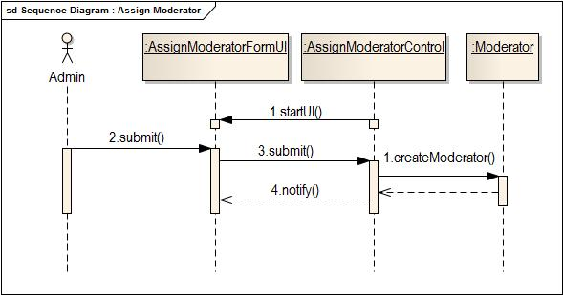

“sign up” use case

sequence Diagram for use case ”sign up”

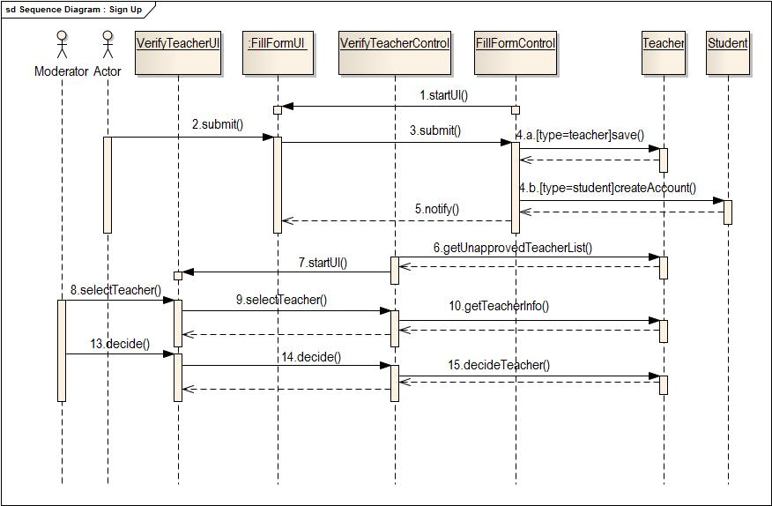

“Sign In” use case

sequence Diagram for use case ”Sign In”

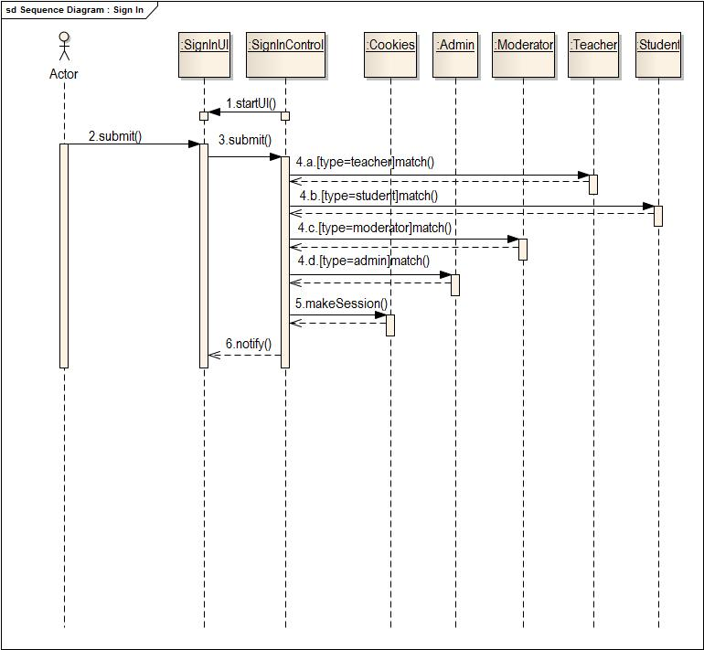

“Sign Out” use case

sequence Diagram for use case ”Sign Out”

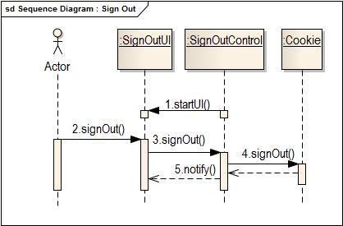

**StateChart Diagrams of Registration Sub-system**

**State chart diagram for moderator entity**

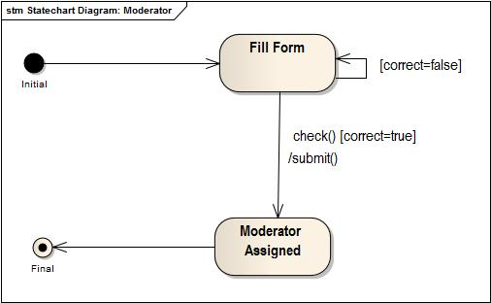

**State chart diagram for teacher entity**

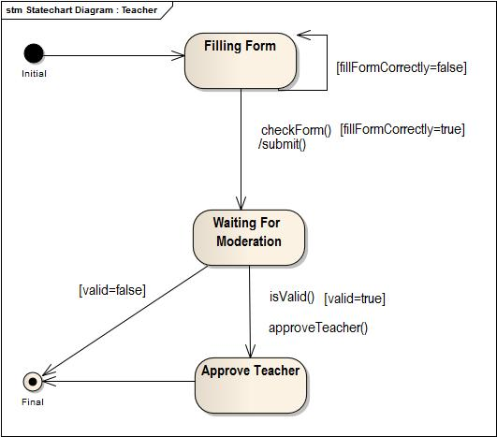

**State chart diagram for student entity**

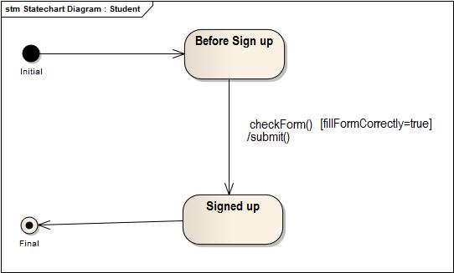

**State chart diagram for cookies entity**

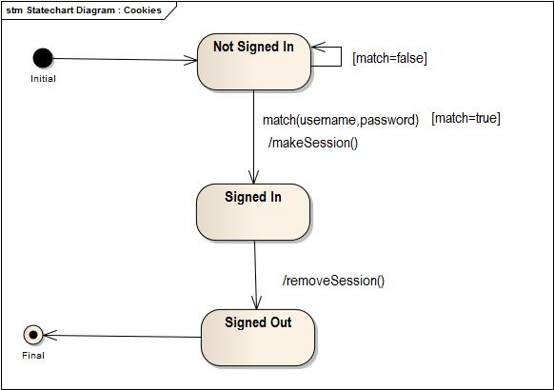

**Activity Diagrams of Registration Sub-system**

**Activity diagram of assign moderator use case**

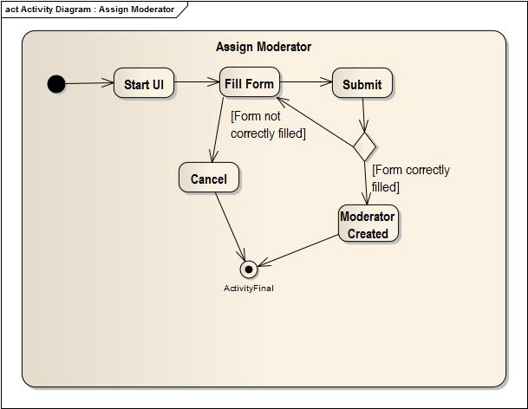

**Activity diagram of sign up use case**

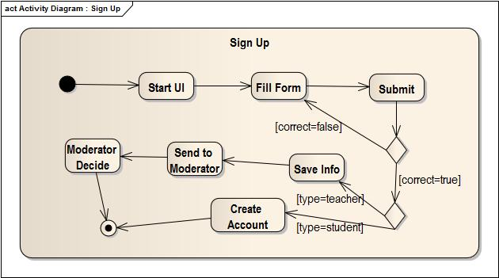

**Activity diagram of sign in use case**

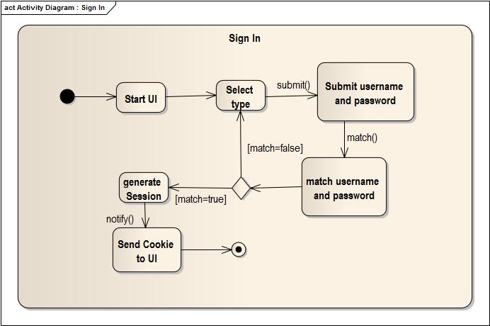

**Activity diagram of sign out use case**

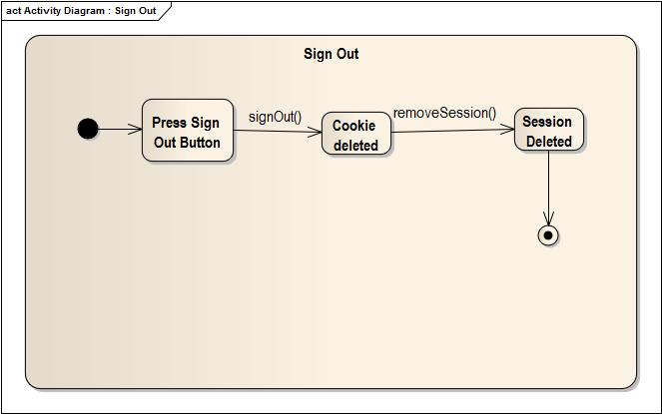

3. INFORMATION SUBSYSTEM

“View Public Profile” use case

sequence Diagram for use case ”View Public Profile”

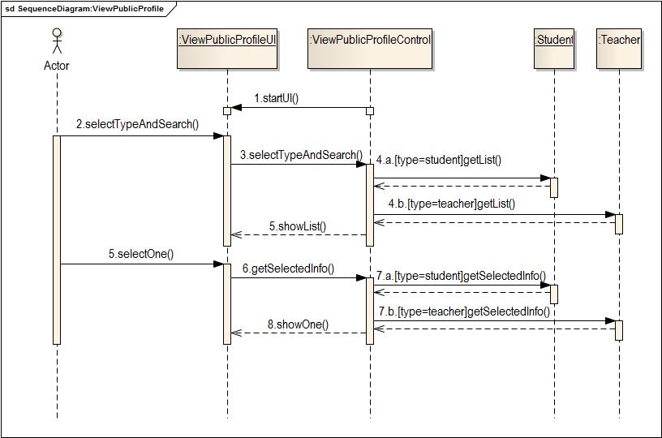

“view and edit own profile” use case

sequence Diagram for use case ” view and edit own profile”

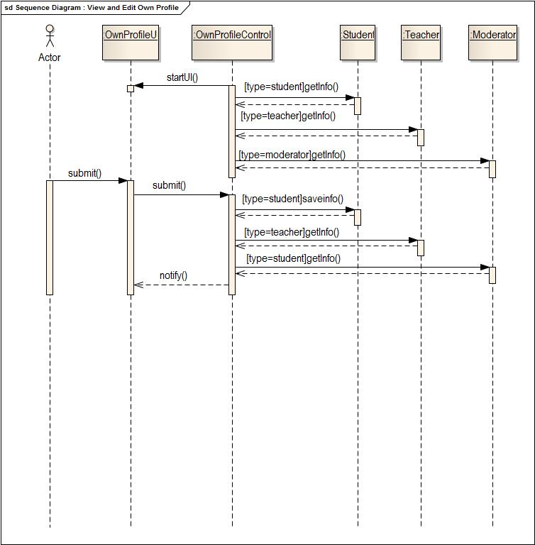

“View Statistics” use case

sequence Diagram for use case“View Statistics”

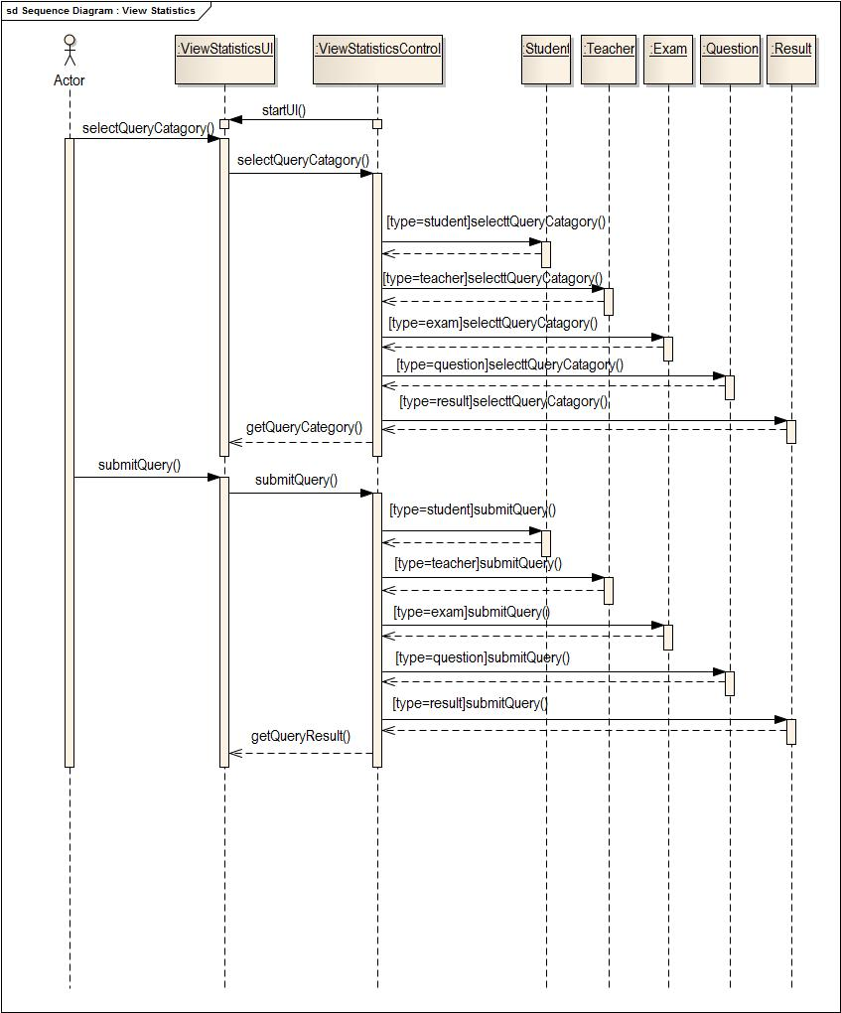

“Talk to us” use case

sequence Diagram for use case“talk to us”

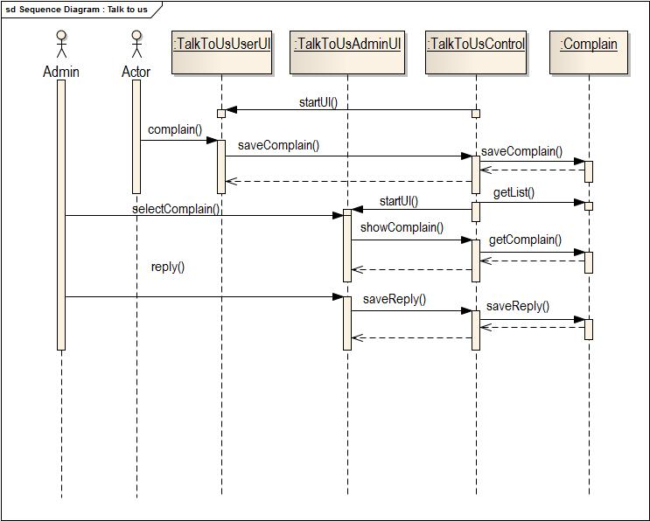

**StateChart Diagrams of Information Sub-system**

State chart diagram of Moderator entity

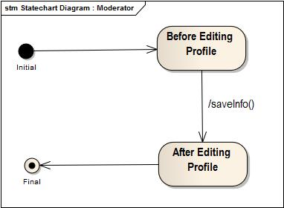

State chart diagram of teacher entity

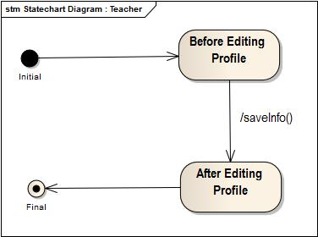

State chart diagram of student entity

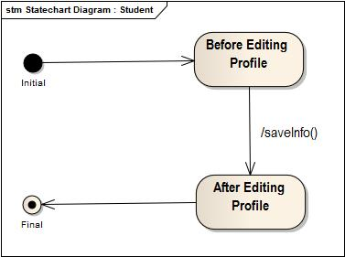

State chart diagram of complain entity

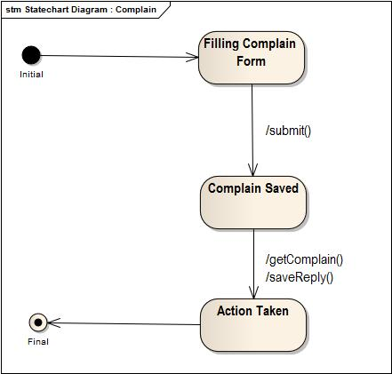

**Activity Diagrams of Information Sub-system**

**Activity diagram of view public profile use case**

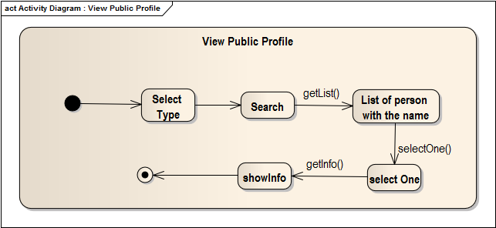

**Activity diagram of View And Edit Own Profile use case**

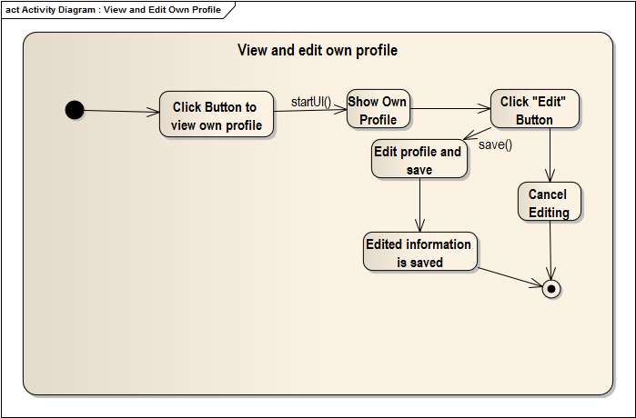

**Activity diagram of View Statistics use case**

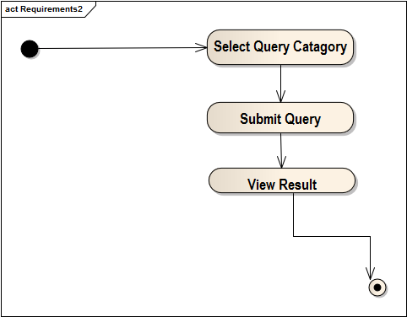

**Activity diagram of Talk to us use case**

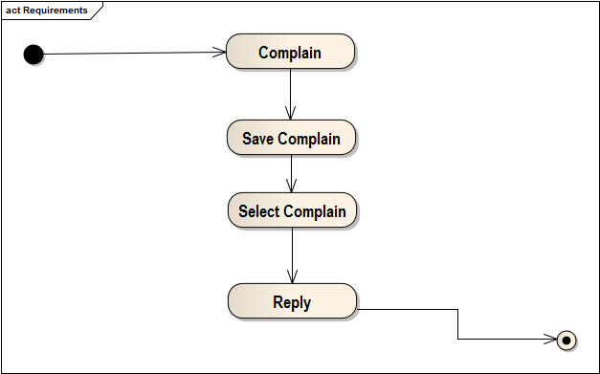

5.DIGITAL CLASSROOM

“Provide material” use case

sequence Diagram for use case“Provide material”

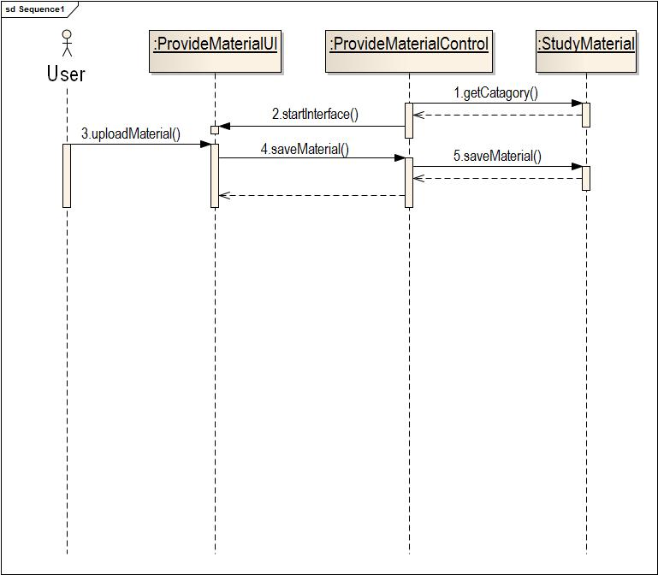

“Approve material” use case

sequence Diagram for use case“Approve material”

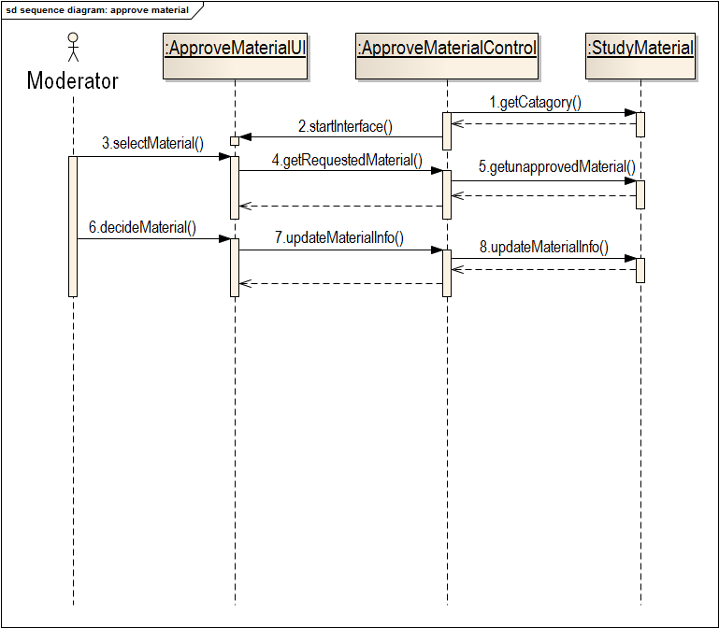

“View material” use case

sequence Diagram for use case“Viewmaterial”

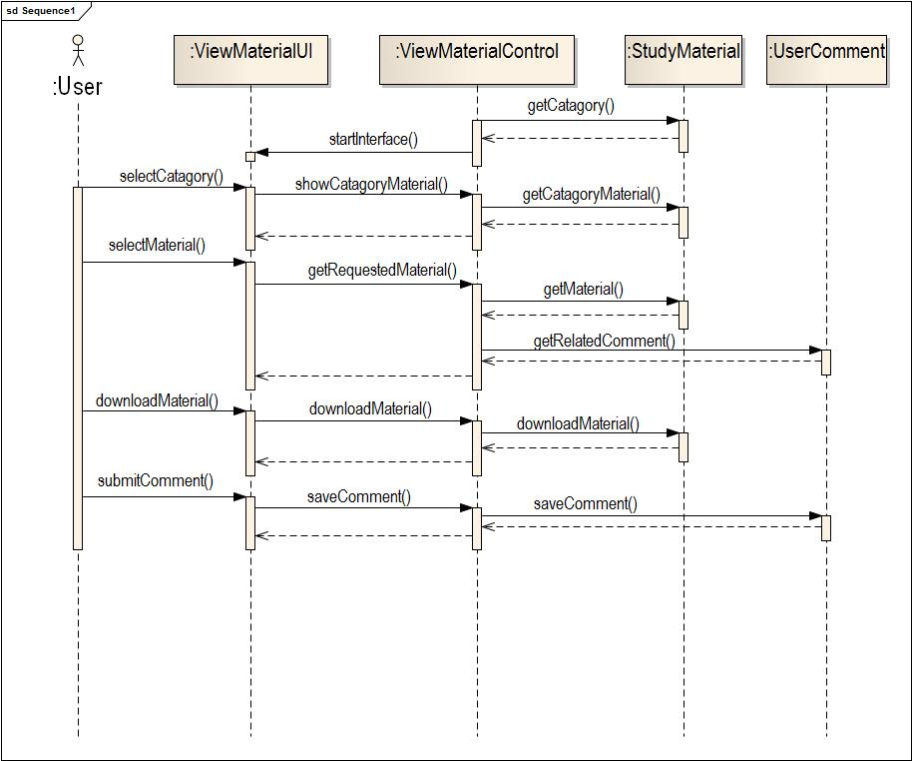

State chart diagram

State chart Diagram for study material entity

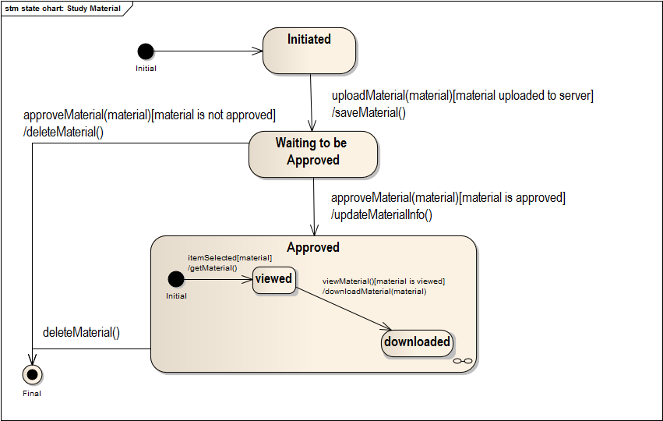

State chart Diagram for User comment entity

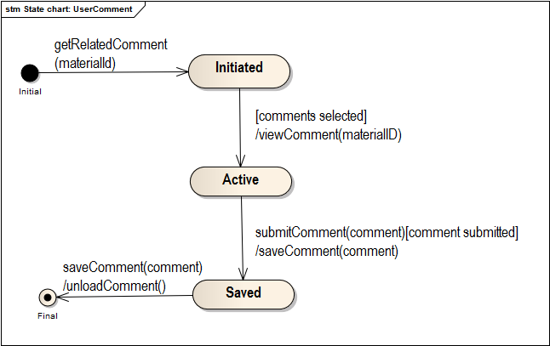

Activity diagram

Activity Diagram for approve material use case

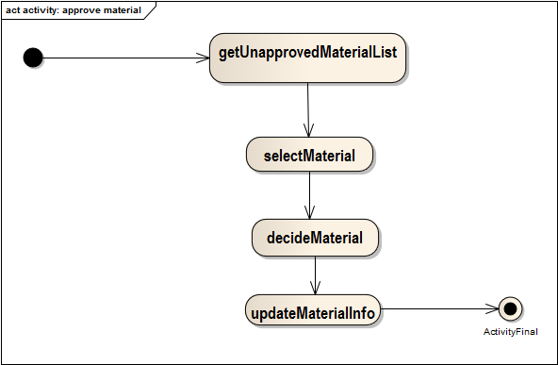

Activity Diagram for provide material use case

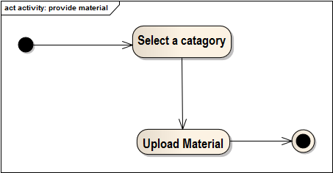

Activity Diagram for view material use case

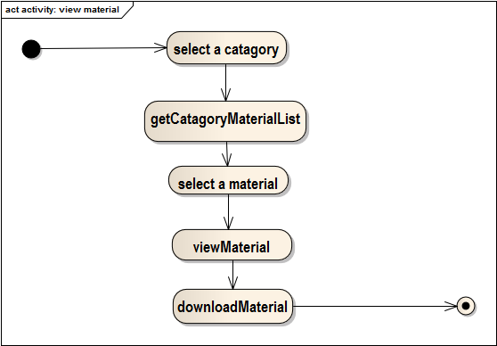

………THE END………